User interface:

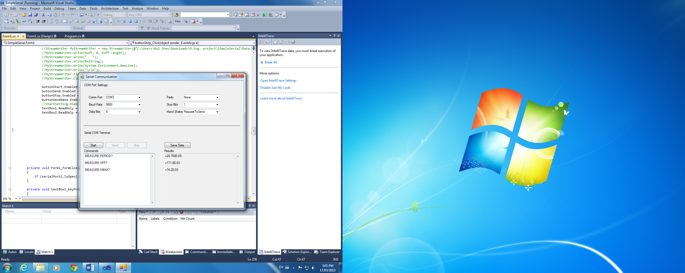

How to use this software:

1. Open the software, and set the communication port, parity, baud rate, stop bits, data bits and flow control.
2. Click “Start” to open the serial port, and enter the commands in the left textbox.
3. Click “Send” to send the command to the instrument, if there are some data replied, they will be listed in the right textbox.
4. Click “Stop” to close the serial port, if the commands, and their corresponding results are needed to be saved, click “Save Data” to choose a path to save the data, after the data are saved, the texts in both textboxes will be cleared. Otherwise, click “Start” to send another command. What is more, the COM port settings can be changed now, click “Start”, and the new settings will be applied.
5. If button “Stop” is clicked, the texts in the left textbox can be edited, so that the saved file will be easier to understand. However, only the command entered after clicking “Start” will be sent to the instrument.

Development environment: Microsoft Visual Studio 2010

.Net Framework

Hardware: Agilent 54624A

Serial connection: USB (RS232)

Operating system: Windows 7/Windows 8.1